

### Semester One Examination, 2019

### Question/Answer booklet

# MATHEMATICS APPLICATIONS

**UNIT 1**

## Section One:

## Calculator-free

Your name

Teacher’s Name Hennighan Hill Scorer Toh

(Please circle)

## Time allowed for this section

Reading time before commencing work: five minutes

Working time: fifty minutes

## Materials required/recommended for this section

***To be provided by the supervisor***

This Question/Answer booklet

Formula sheet

***To be provided by the candidate***

Standard items: pens (blue/black preferred), pencils (including coloured), sharpener,  
correction fluid/tape, eraser, ruler, highlighters

Special items: nil

## Important note to candidates

No other items may be taken into the examination room. It is **your** responsibility to ensure that you do not have any unauthorised material. If you have any unauthorised material with you, hand it to the supervisor **before** reading any further.

## Structure of this paper

| Section | Number of questions available | Number of questions to be answered | Working  time (minutes) | Marks available | Percentage of examination |
| --- | --- | --- | --- | --- | --- |
| Section One:  Calculator-free | 8 | 8 | 50 | 52 | 35 |
| Section Two:  Calculator-assumed | 13 | 13 | 100 | 98 | 65 |
|  | | |  | **Total** | 100 |

| Markers use only | | |
| --- | --- | --- |
| Question | Maximum | Mark |
| 1 | 6 |  |
| 2 | 6 |  |
| 3 | 9 |  |
| 4 | 6 |  |
| 5 | 6 |  |
| 6 | 7 |  |
| 7 | 7 |  |
| 8 | 5 |  |
| S1 Total | 52 |  |
| S1 Wt (×0.6731) | 35% |  |
| S2 Wt | 65% |  |
| Total | 100% |  |

## Instructions to candidates

1. The rules for the conduct of examinations are detailed in the school handbook. Sitting this examination implies that you agree to abide by these rules.

2. Write your answers in this Question/Answer booklet preferably using a blue/black pen.  
Do not use erasable or gel pens.

3. You must be careful to confine your answer to the specific question asked and to follow any instructions that are specified to a particular question.

4. Show all your working clearly. Your working should be in sufficient detail to allow your answers to be checked readily and for marks to be awarded for reasoning. Incorrect answers given without supporting reasoning cannot be allocated any marks. For any question or part question worth more than two marks, valid working or justification is required to receive full marks. If you repeat any question, ensure that you cancel the answer you do not wish to have marked.

5. It is recommended that you do not use pencil, except in diagrams.

6. Supplementary pages for planning/continuing your answers to questions are provided at the end of this Question/Answer booklet. If you use these pages to continue an answer, indicate at the original answer where the answer is continued, i.e. give the page number.

7. The Formula sheet is not to be handed in with your Question/Answer booklet.

**Section** **One: Calculator-****free** **35% (****52 Marks)**

This section has**eight (****8)** questions. Answer **all** questions. Write your answers in the spaces provided.

Working time: 50 minutes.

**Question 1 (6 marks)**

Evaluate

(a) when (2 marks)

(b) when . (2 marks)

(c) when and . (2 marks)

**Question 2 (6 marks)**

One Australian dollar can buy US dollars.

(a) How many US dollars can be bought for

(i) Australian dollars? (1 mark)

(ii) Australian dollars? (1 mark)

(b) How many Australian dollars are needed to buy US dollars? (1 mark)

One Australian dollar can buy South African rand.

(c) At an airport a traveller wants to buy rand, but the exchange desk also charges them a commission of . Determine the total cost, in Australian dollars, for the traveller to buy this amount of currency. (3 marks)

**Question 3 (9 marks)**

Four matrices are defined as and .

(a) State

(i) which matrix has more rows than columns. (1 mark)

(ii) the dimensions of the row matrix. (1 mark)

(b) Calculate , where is the identity matrix. (3 marks)

(c) Calculate . (2 marks)

(d) It is required to multiply all four matrices together so that the final product is a square matrix with the largest possible number of columns. State the order in which the matrices should be multiplied and state the number of columns in the final product. (2 marks)

**Question 4 (6 marks)**

During the week, casual employees at a recycling plant are paid a wage of per hour plus for every kg of electronic waste they collect. Over the weekend, both rates are increased by .

A casual worked for hours on Sunday, collecting kg of electronic waste, and then a further hours on Monday when they collected kg of electronic waste.

(a) Determine the hourly pay rate for weekends. (1 mark)

(b) Calculate how much the casual earned on Monday. (2 marks)

(c) Calculate the total earned by the casual over the two days. (3 marks)

**Question 5 (6 marks)**

Hockey teams A and B had each played games in a league. Team A had won , lost and drawn the remainder of its games. In total, the two teams had won and drawn games.

(a) Show this information in a matrix , with columns ordered win, lose, draw and rows ordered team A and team B. (2 marks)

(b) Each team gains points for a win, point for a draw and no points for a loss. Show this information in matrix that can be multiplied by matrix . (1 mark)

(c) Calculate and state which team is leading the other in the league. (3 marks)

**Question 6 (7 marks)**

An investor held , and shares in companies A, B and C respectively.

Company A announced a dividend per share of of the share price, company B paid the investor a dividend of and company C announced a dividend of cents per share.

(a) Determine the total dividend the investor can expect from company A if the current price of a share is . (2 marks)

(b) Calculate the dividend paid per share by company B. (2 marks)

(c) Company C did not pay the investor the total dividend but instead paid the balance remaining after withholding a government tax of of the dividend. Calculate the balance due to the investor. (3 marks)

**Question 7 (7 marks)**

(a) In a house, the width of a room was cm. On a scale drawing of the house, the same room had a width of mm.

(i) Determine the scale, in simplest form, used to make the drawing. (2 marks)

(ii) On the scale drawing, a passageway had a length of mm. Determine the length of the passageway in the house, giving your answer in metres. (2 marks)

(b) A plan for a different house was drawn to a scale of . A room on the plan measured mm by mm. The floor of the room is to be tiled at a cost of per square metre. Calculate the cost of the tiling. (3 marks)

**Question 8 (5 marks)**

Rectangular logo , with cm and cm, has a white background with grey triangle and grey sector of circle , as shown below.

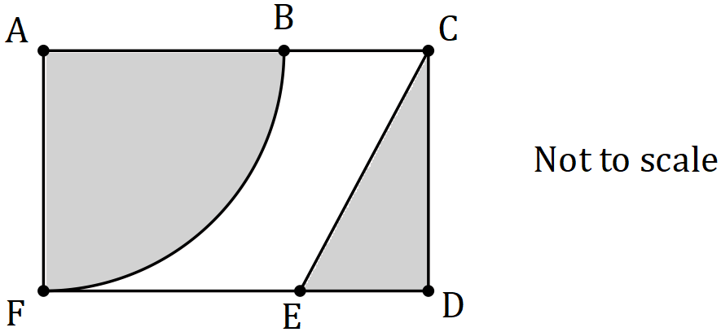

Given that and assuming that , determine what percentage of the area of the rectangular logo is grey.

Supplementary page

Question number: _________

© 2019 WA Exam Papers. Kennedy Baptist College has a non-exclusive licence to copy and communicate this document for non-commercial, educational use within the school. No other copying, communication or use is permitted without the express written permission of WA Exam Papers. SN245-133-1.